Level 10: (lesson 2) Interest on Interest?

Lesson overview
This lesson follows from “what is mathematical modelling’ where we focused on the messy real-world and describing the modelling process. This lesson focus’ on standard financial models. The concept of simple interest is extended to compound interest where interest on interest is calculated. A spreadsheet is used to explore the situation where interest is calculated. on interest. Hence the compound interest formula, a standard financial model, is developed.
Victorian Curriculum 2.0 Content Descriptions
Use mathematical modelling to solve applied problems involving inverse proportion, growth and decay, including in financial contexts to establish the compound interest formula as repeated applications of simple interest; formulate problems, choosing to apply linear, quadratic or exponential models; interpret solutions in terms of the situation; evaluate and modify models as necessary and report assumptions, methods and findings (VC2M10A15)

Important background to consider prior to the lesson
When using a spreadsheet, the notation for repeated multiplication is ‘^’ rather than using an exponent (e.g., 4^2 rather than the mathematical notation of $4^{2}$.)
Students may not understand that interest rates are given as a percentage per annum (p.a.). If the interest is compounded more than once a year, the rate needs to be converted into rate percentage per period. For example, 10% p.a. compounded monthly, will be 0.83333% per quarter (10 ÷ 12 % = 0.83333 %)
The number of compounding periods is related to how often interest is compounded. For example, a loan with a rate of 10% p.a. compounded monthly over 5 years, will have 60 compounding periods ($5×12=60$).
If students are unfamiliar with spreadsheet formula, draw their attention to the meaning of the ‘$’. In this calculation $B$2, fixes the calculation to always refer to the value in cell B2, irrespective of what else changes. In other formula a single ‘$’ will fix a row (e.g., B$2) or column (e.g., $B2).
Whilst it can be tempting to overwrite early calculations, it is more sensible to duplicate these and then edit. This allows students to have each set of calculations visible on their spreadsheet.

Materials required for the lesson
Student
- Access to spreadsheet software (e.g., Excel, Google sheet) or a function grapher with embedded spreadsheet (e.g., graphing calculator)
Teacher
- Slidedeck

Activate prior learning related to simple interest calculation | Start by reminding students that their previous mathematical modelling lesson, that they focused on the messy real-world and describing the modelling process. In this lesson, we focus on standard financial models. In some real-world situations, modellers need to create mathematical models. In finance situations, we typically use standard models.  Ask students to recall the standard model for calculating the amount of simple interest earned on an investment. Expect students to describe the familiar model. The algebraic formula, is $I=PRT$ where $I$ represents the interest rate, $P$ the principal, that is the amount borrowed or invested, $R$ is the interest rate given as a percentage per annum (p.a.) and $T$is the time of the loan or investment in years.  Ask student pairs to create and solve 2 problem situations where simple interest must be determined to show they understand the model and how to use it.  Make note if students clarify via their understanding that:  - An interest rate provided as a percentage (e.g., 4%) must be re-represented as a decimal fraction (e.g., 0.04). Alternatively, the related model $I=P×\frac{r}{100}×T$  - When the time is not given in years (e.g., 18 months), this will need to be converted to a time fraction in years (e.g.,18 ÷ 12 = 1.5 years)  - When calculating an amount of money, either round the amount to 2 decimal places or to the nearest dollar.  Note rounding should only occur in the final step of a calculation.
Link the concept of simple interest to introduce compound interest | Explain that in simple interest situations, typically the interest is paid at the end of the loan period.  Ask, What if interest was paid more frequently, not just at the end of the term, and the interest is added to the principal amount, and hence can itself earn interest in the future? This is referred to as earning interest on your interest. In this lesson we will use a spreadsheet to explore this idea.  Consider this task:  The iPad problem.  Imagine your parents, knowing they would need to get you an iPad for Years 7-10, had invested $750 at 5.25% p.a. over 3 years whilst you were in Year 3-6. Was this a smart move on their part?  First consider the situation if the investment earned simple interest. Set up a spreadsheet to ‘do’ the calculations.  Provide students sufficient time (this will depend on their previous spreadsheet experience) before displaying the expected spreadsheet entries and output (via the teacher or a student shared screen).  The example screen shows the likely outputs. Here the top left of the spreadsheet is used but that is irrelevant. The labels shown in column A here are critical for understanding and communication. Cells B1 to B3 hold values whereas cell B5 uses a formula that communicates – find the product of the three relevant cells, renaming the interest rate p.a. as a decimal fraction.  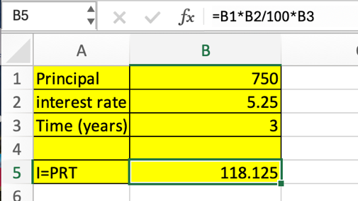  Check that students understand they can display a single spreadsheet formula by clicking in a cell (see image on left) or all formulas by selecting the Formula menu and the Show Formulas 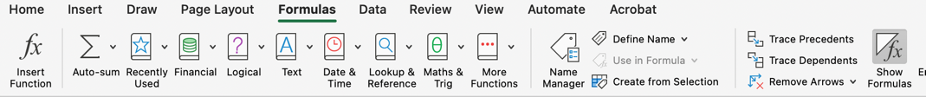
Develop conceptual understand of compound interest | Challenge students to set up cells in the spreadsheet to show the amount of interest at the end of year 1 and then what happens if this amount is added to the initial amount invested, the principal of $750 and interest in year 1 is determined on this new value.  Encourage students to set up something similar and add annotations to help track their thinking and calculations.  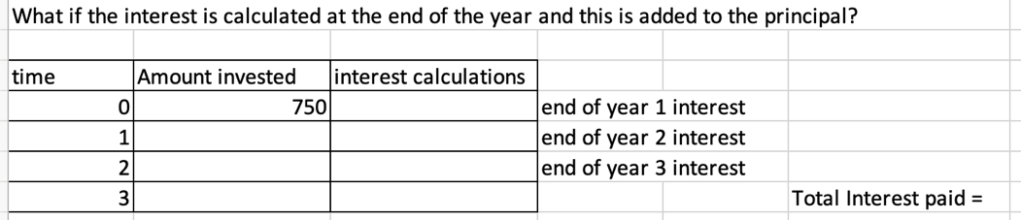  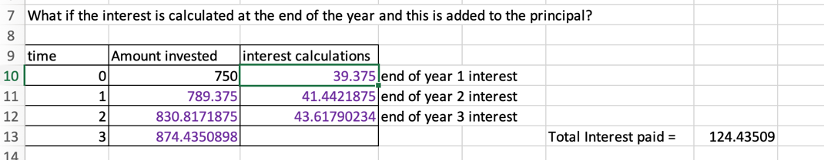  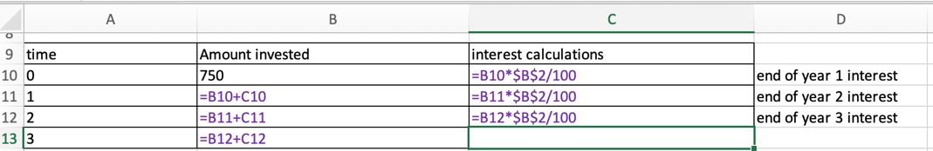Ask students to compare the impact of the ‘interest on your interest’ calculations to the simple interest calculation.  Next, consider if the interest is paid more often – start with 6 monthly – how do you need to modify the spreadsheet? What changes? What stays the same? What if interest is calculated monthly? Fortnightly? Weekly? Daily?
Recording the effect of interest on interest  Teacher-led discussion | Create a table (to be recorded in the student's maths workbook) that summarises the results of the calculations. Observe: What changes? What stays the same?  Complete the statement, For a fixed principal, interest rate, and term, the effect of more frequent repayments is ....  Bring the whole class together and ask, The spreadsheet is very efficient, and it clearly shows how ‘interest on interest’ works. Can we make some observations and find a more efficient way to complete the calculations?  Depending on the class, either lead a discussion as shown here, or provide students time to work on this task in pairs and propose a general formula.  Use the slides provided to work through the development of a general formula for compound interest by generalising the spreadsheet formula. The initial example consider is provided over a serious of slides allowing student to work ahead of the teacher if they can. The focus is on understanding how the repeated calculations can be concatenated to a single general formula.  The initial example has interest only paid yearly. Following this, student should check the same general formula arises even when interest is paid more often.  The goal is for students to know the term for ‘interest on interest’ as compound interest.
Reflect | Ask students to write a paragraph explaining the key difference between simple and compound interest and how this might impact them if they borrow or save money in the future.

